**Section 6**

**HEARIACHEY LEVEL**

select level id,name,deptid

from emp

start with id=100

connect by prior id=deptid;

**HIERACHIAL USING START WITH KEYWORD**

select id,name,deptid

from emp

start with id=100

connect by prior id=deptid;

**FULL OUTER JOIN**

select e.id,e.name,d.deptid,d.dept_name

from emp e full outer join dept d

on (e.deptid=d.deptid);

**RIGHT OUTER JOIN**

select e.id,e.name,d.deptid,d.dept_name

from emp e right outer join dept d

on (e.deptid=d.deptid);

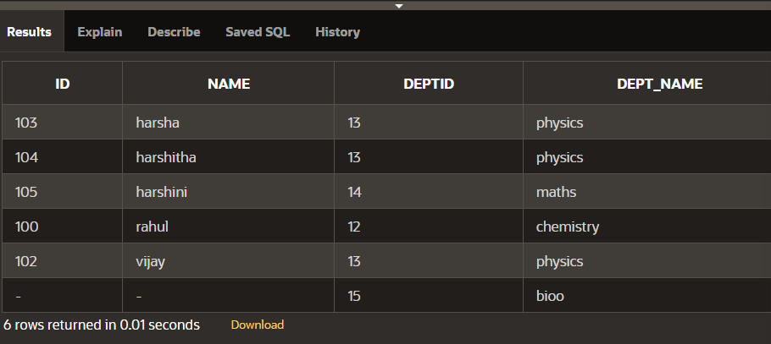

**LEFT OUTER JOIN**

select e.id,e.name,d.deptid,d.dept_name

from emp e left outer join dept d

on (e.deptid=d.deptid);

**ON CLAUSE**

select id,name,dept_name

from emp e join dept d

on(e.deptid=d.deptid);

**USING CLAUSE**

select id,name,deptid,dept_name

from emp join dept using (deptid);

**CROSS JOIN**

select id,name,dept_name

from emp cross join dept;

**NATURAL JOIN**

select id,name,deptid,dept_name

from emp natural join dept;

